Lab 1 Spring Boot
- Design Database Structure for Medicare System
- Install IntelliJ Idea
- Steps Towards creating First SpringBoot Project
Section a.)
A Medicare or healthcare system in Spring Boot is typically a full-stack web application used to digitize hospital or clinic operations. It generally incorporates features like patient registration, appointment scheduling, billing, and inventory management

Modules of Medicare System
- Patient Management
- Doctor Management
- Appointment Management
- Prescription Management
- Medicine Management
- Billing & Payment Management
- Admin Management
ER Diagram for The Project
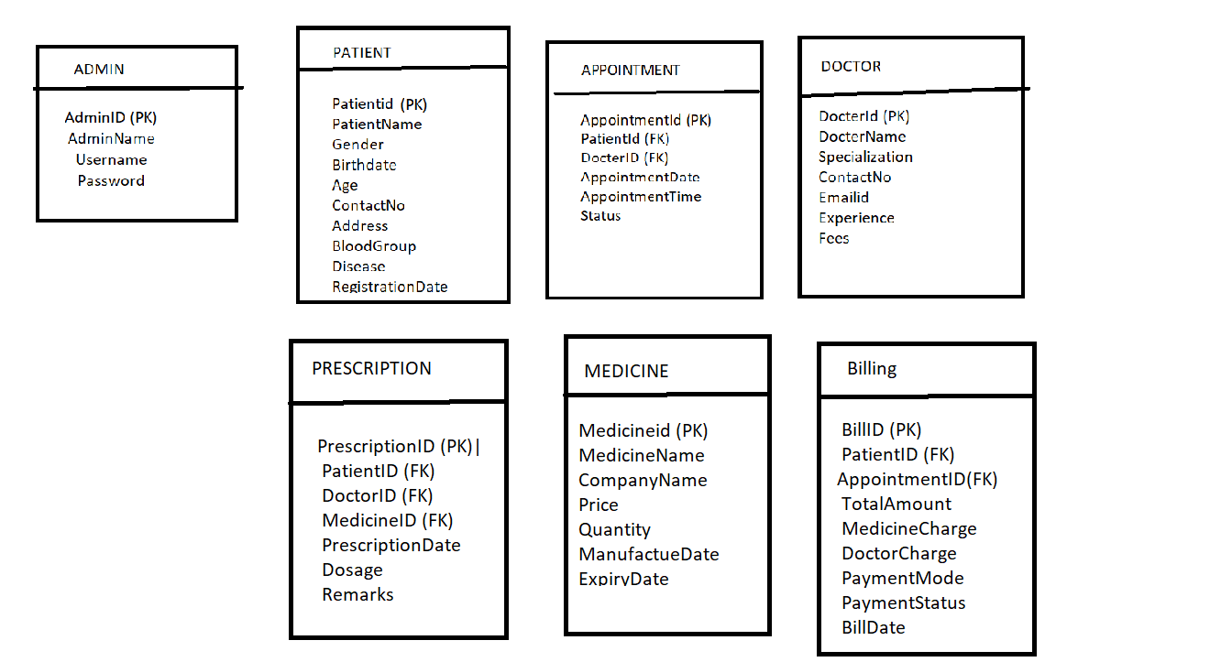
Section b.)
Step 1
Download IntelliJ idea from Google Chrome
Selecting Below

Click on First Link below on this page select OS for example Windows and then Click on Button download
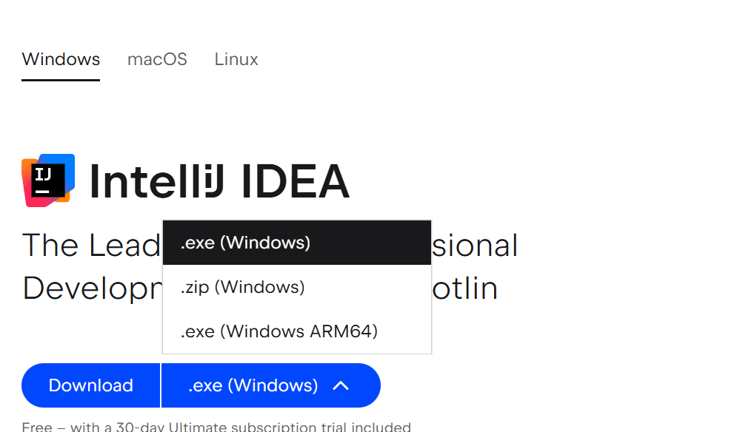
Application downloads
Click On Downloaded exe file follow step of Wizards and Install IntelliJ On your system.
After Completion of Installation Can Check Application by creating Simple Java Program
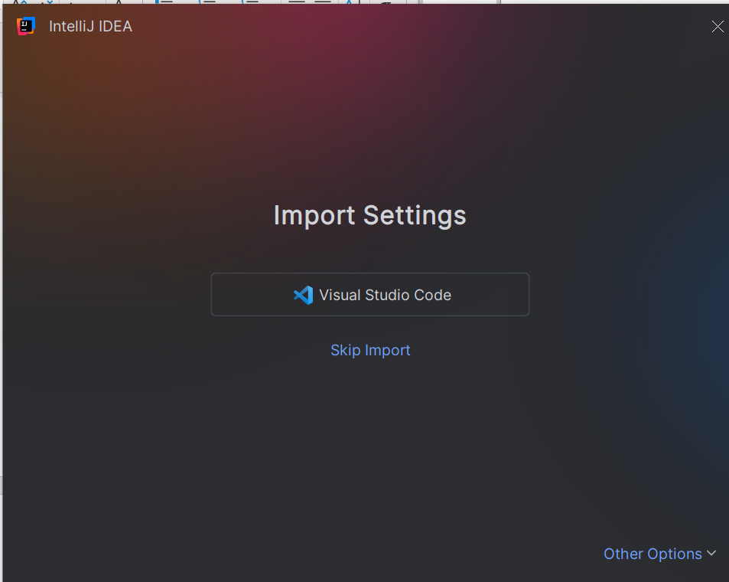
Click on Skip Import Next Screen will be as below
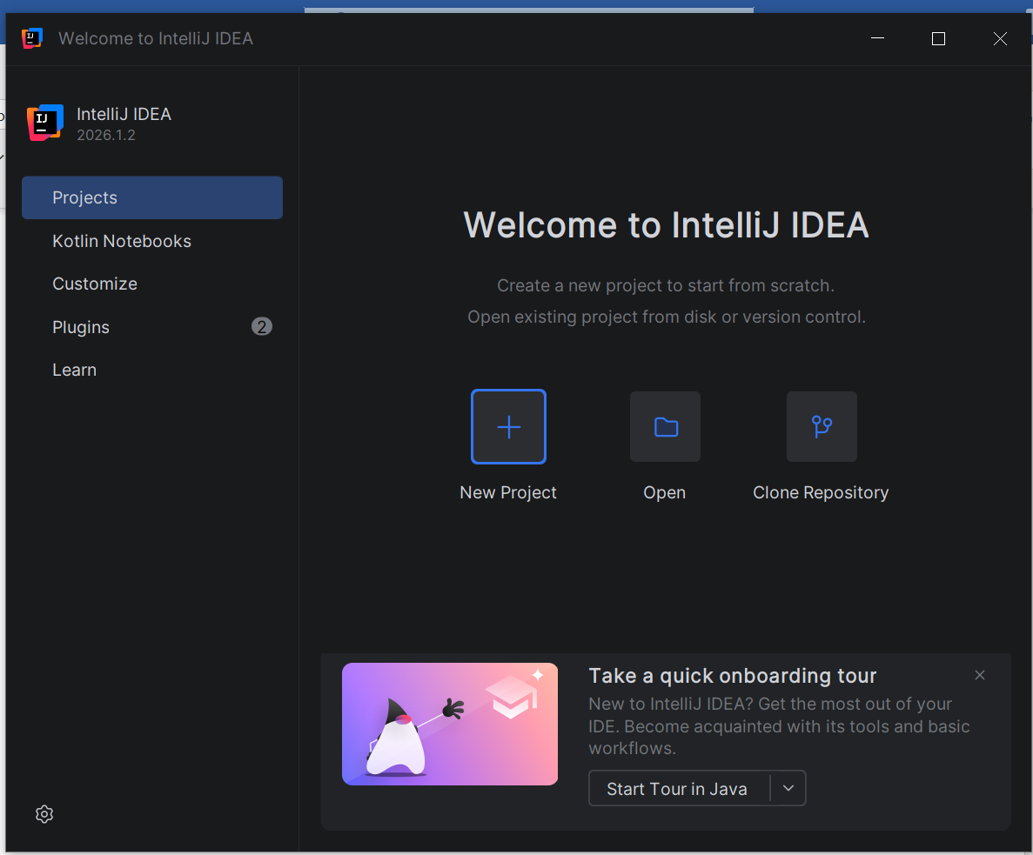

Select New Project button
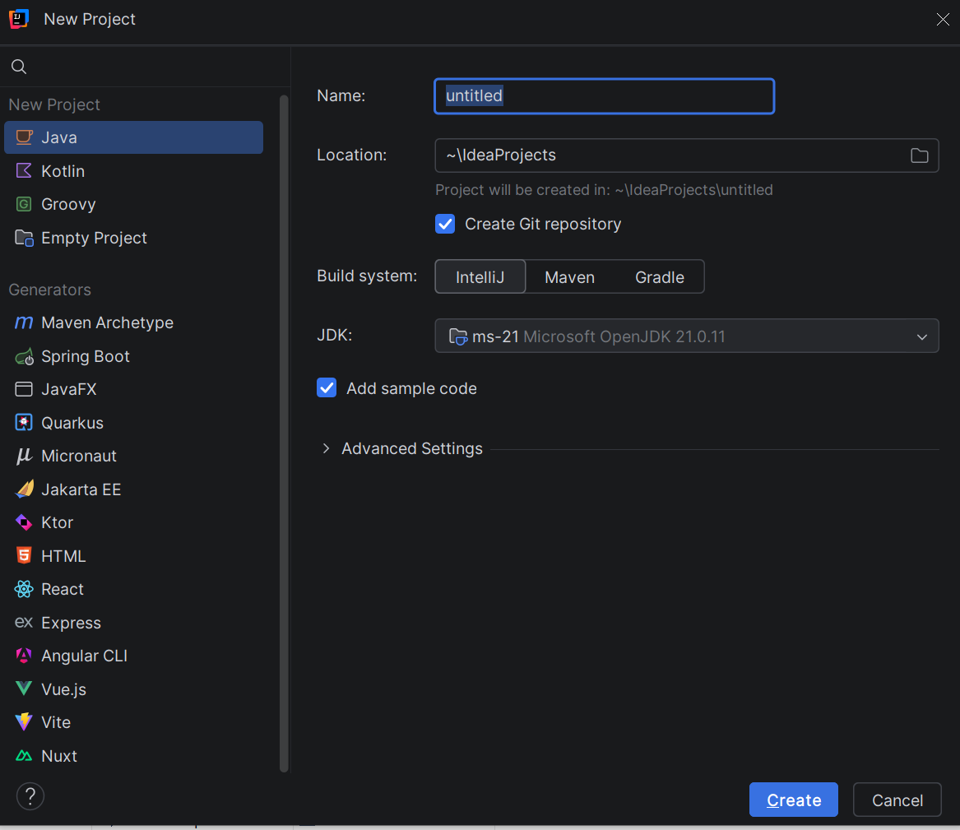
Give Appropriate Name to Project
Select Location to Store project in Specific Folder
Select JDK Version 17 or Above
Click on Button create
We will get screen as Below
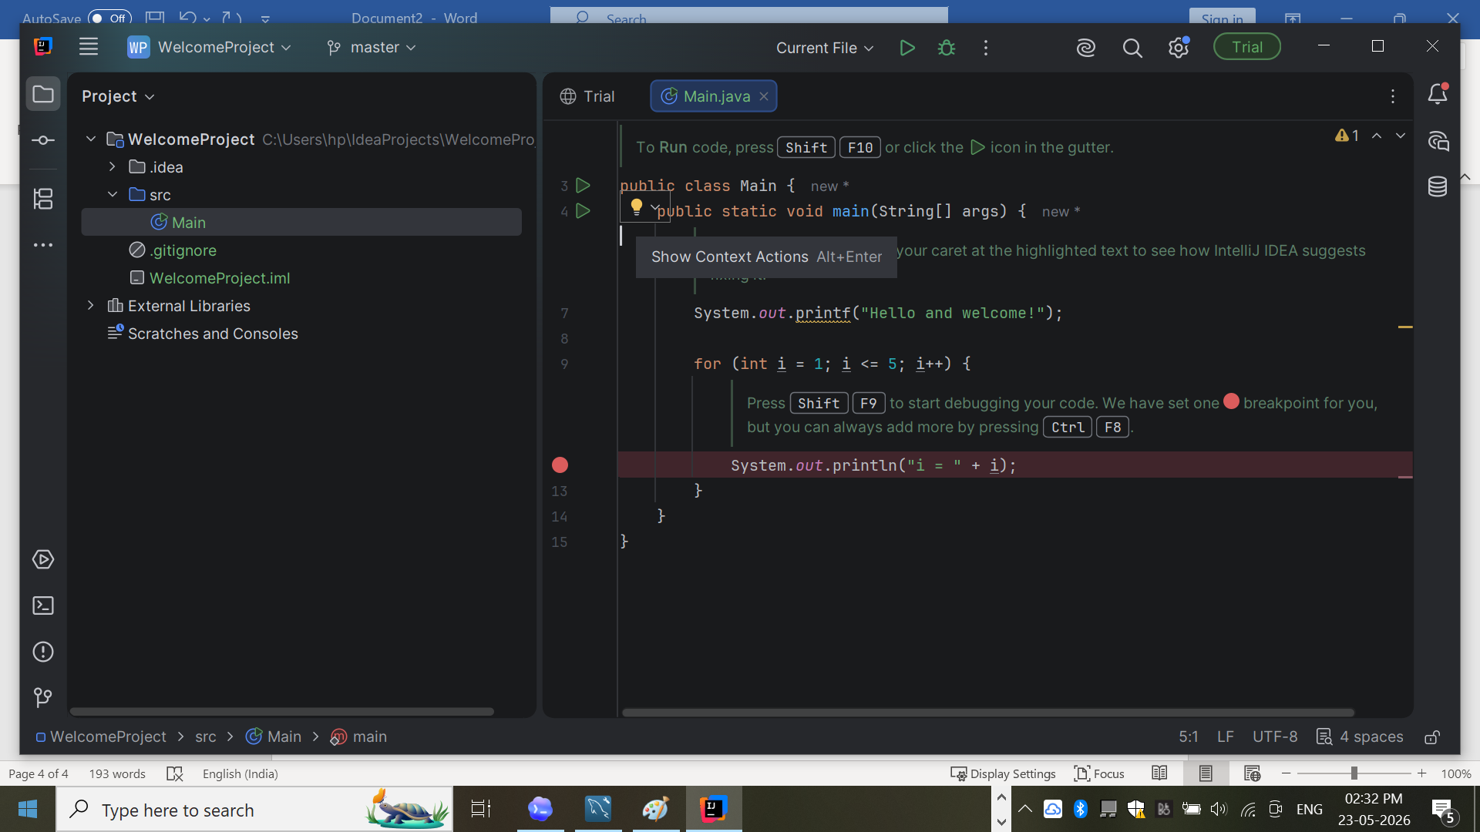

Clear provided code in Main write our own line of Code and Check Execution

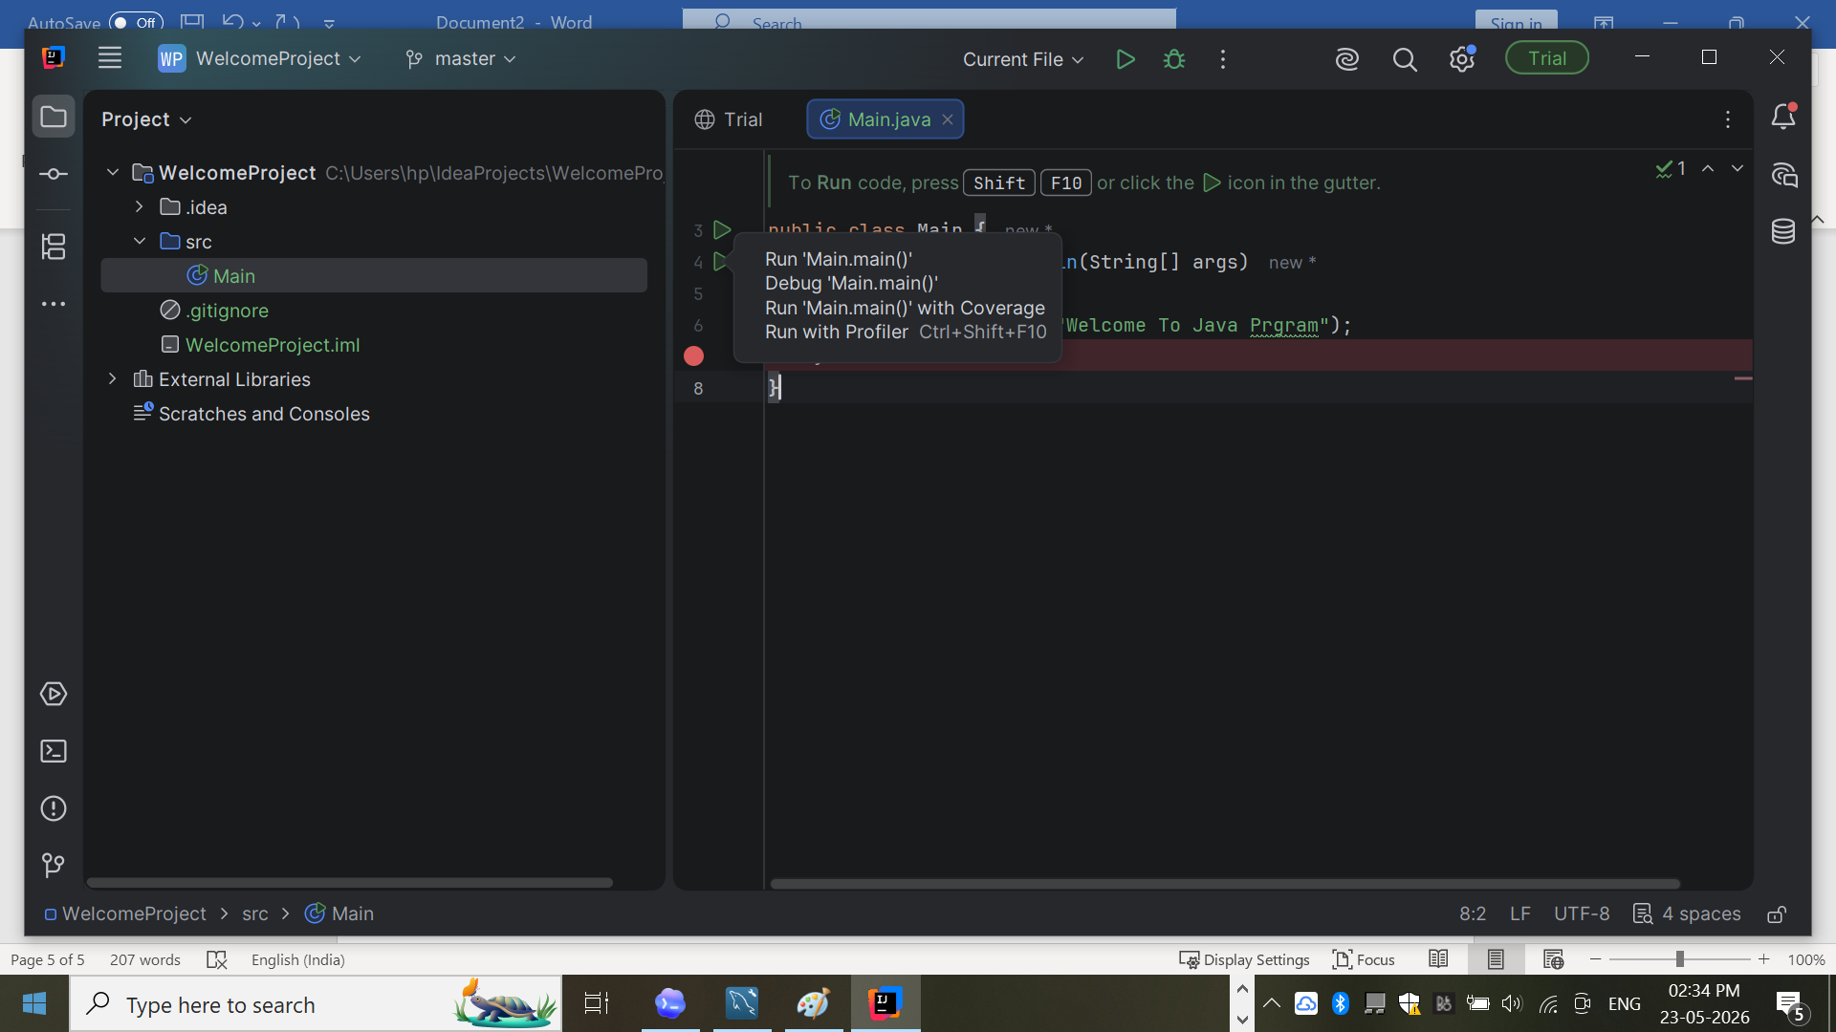

Click on green button to execute our code
Will get o/p as below marks installation successful
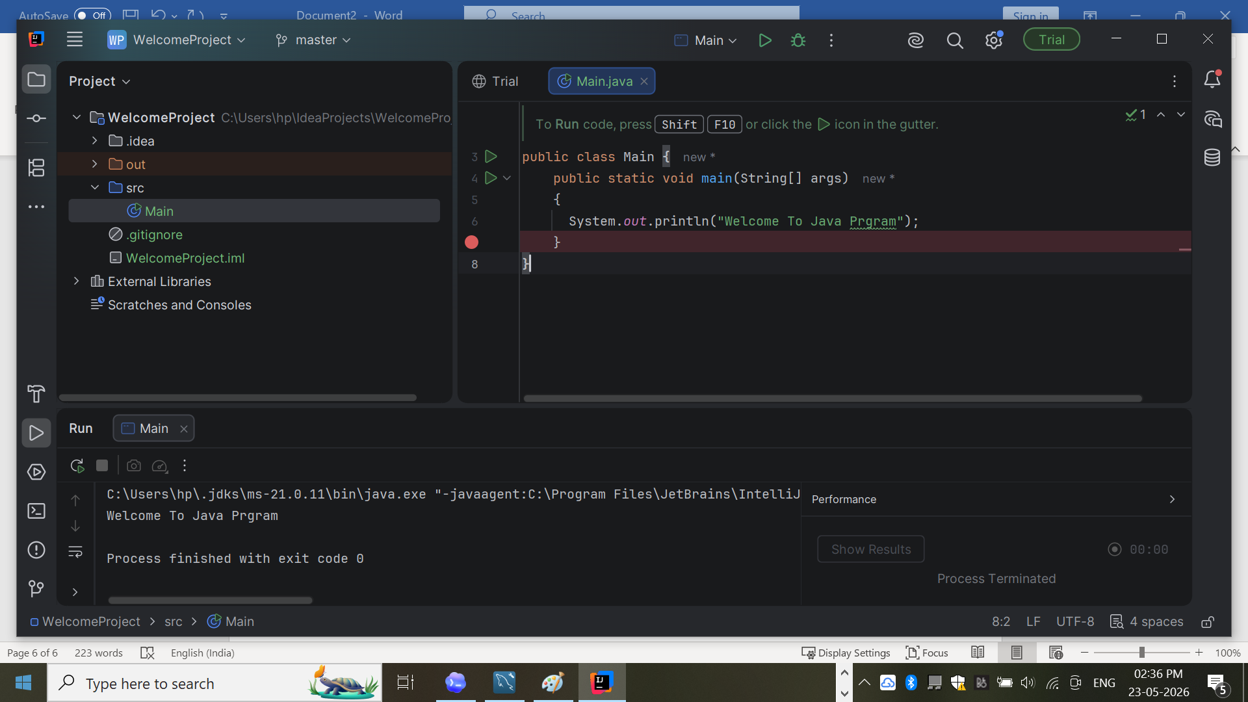

Section c
Steps Towards creating First SpringBoot Project

Step1 Go to google chrome and search for spring Intialzr
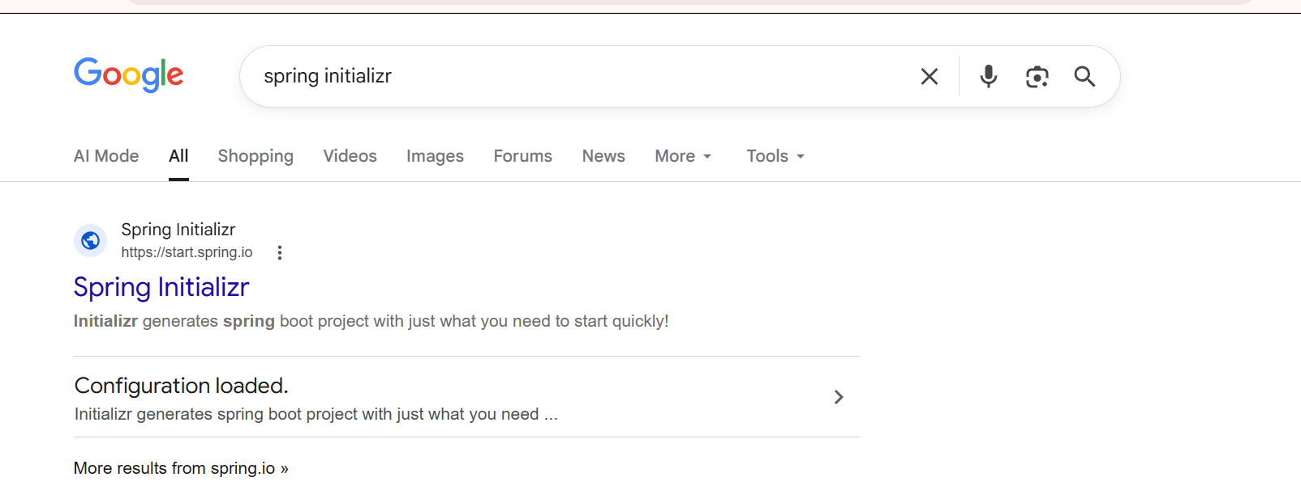
Step2 click on first Link upon clicking will open Spring Initializ page

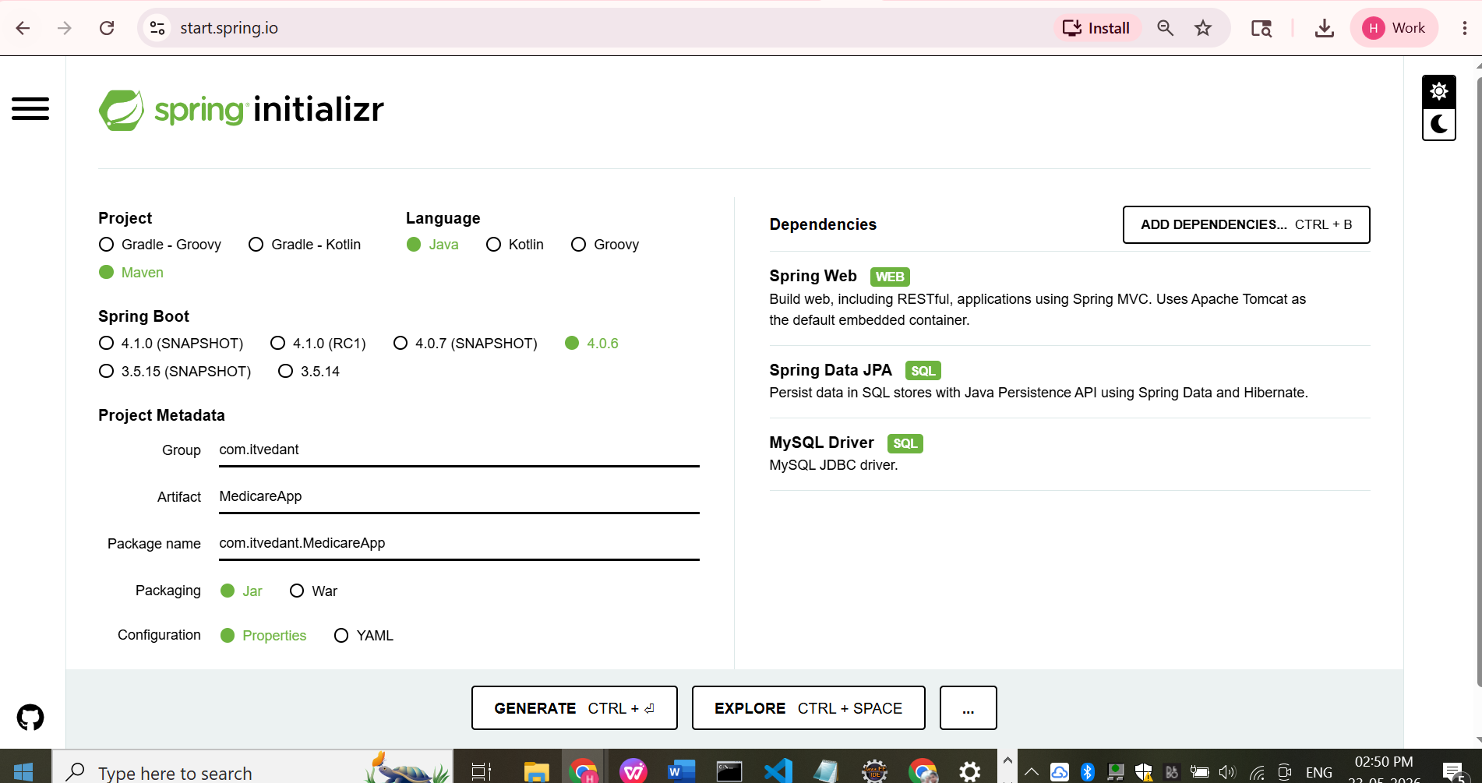

Make Sure Project Selected is Maven, Language Selected is Java
Select Spring Boot Version
Packages type should be selected as jar
Configuration will be written in Properties file
Also select appropriate java version
Clicking on Add Dependencies Button will able to add al the dependencies required for project
As of now added 3 Dependencies
- Spring Web
- Spring Data JPA
- MySql Driver

After Filling all info appropriately click on button Generate. This will generate spring boot maven project in the jar file and downloads project in Download folder.
We can open this project in either IntelliJ Ide or Eclipse Idea or VS Code Ide

